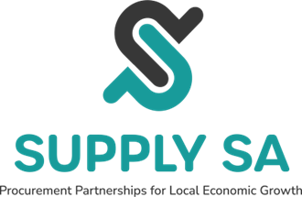

THE SOUTH CENTRAL TEXAS REGIONAL CERTIFICATION AGENCY, INC.
DBA SUPPLY SA
BOARD OF DIRECTORS’ MEETING

Monday, Aug 31, 2026 South Central Texas Regional Certification
2:00 p.m. – 3:30 p.m. Agency dba Supply SA
In-Person Meeting
San Antonio River Authority
100 E. Guenther St., San Antonio, TX 78204

AGENDA

The Board of Directors of the South Central Texas Regional Certification Agency, Inc. dba Supply SA will hold a Board of Directors meeting on Monday, August 31, 2026, at 2:00 p.m., In-Person, at San Antonio River Authority, 100 E. Guenther St., San Antonio, Texas 78204. Verification of Notice of Meeting and Agenda are on file and available via www.supply-sa.org. The Board will consider, discuss, and take appropriate action regarding the following items, unless otherwise noted therein:
- Call to Order
- Approval of April 20, 2026 Meeting Minutes
- Public Comment
- Chair Comments
- Individual Items:
A. FY2027 Annual Budget — Consideration and Adoption
B. FY2026 Q3 Financial Summary
C. FY2027 Strategic Goals — Consideration and Adoption
D. Texas State Legislative Session: Small Business Procurement Policy Priorities
VI. Director Update
VII. Future Meeting Dates
VIII. Adjournment

